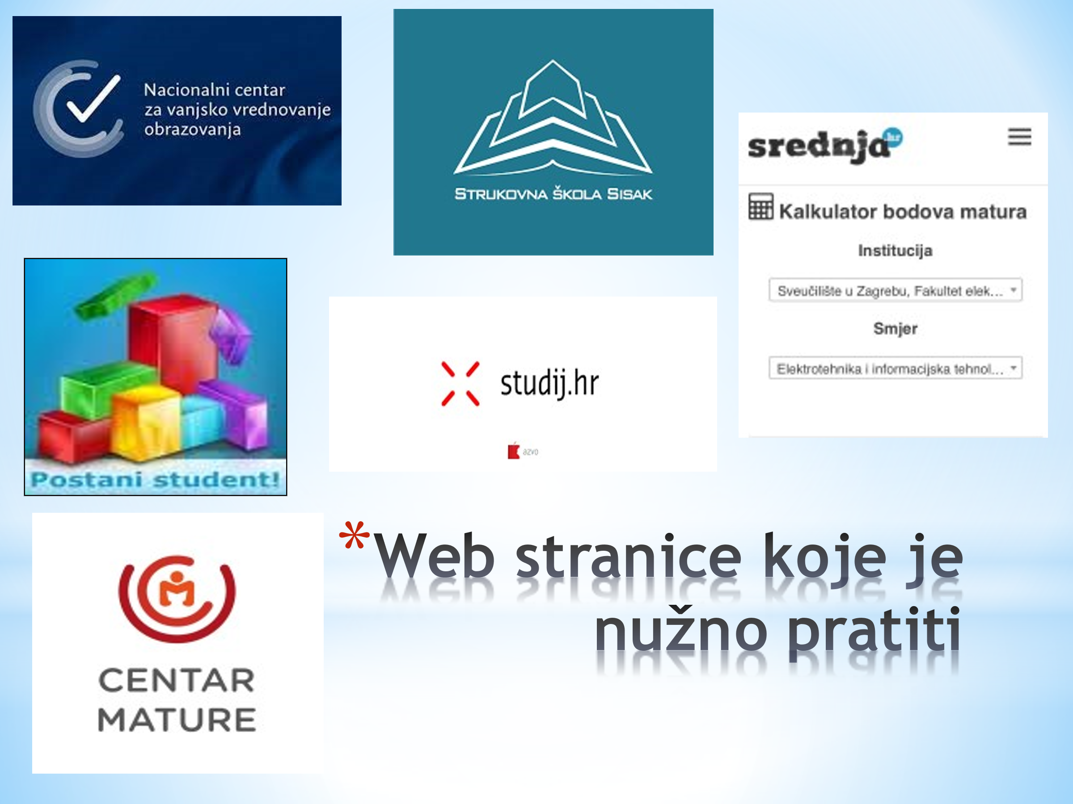

www.ncvvo.hr
https://www.ncvvo.hr/wp-content/uploads/2020/12/Uvod-u-drz%CC%8Cavnu-maturu.pdf
https://www.ncvvo.hr/ispitni-katalozi-za-drzavnu-maturu-2022-2023/
https://www.ncvvo.hr/kategorija/drzavna-matura/provedeni-ispiti/

https://www.postani-student.hr/Ucilista/Default.aspx

https://www.studij.hr/

